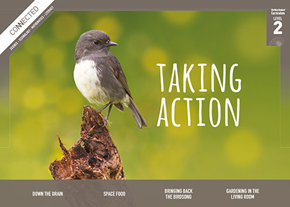
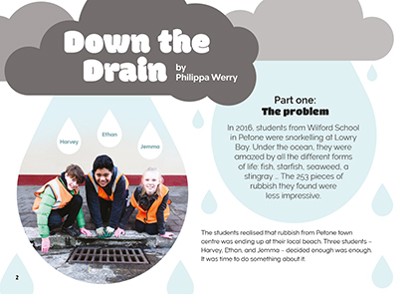
Connected
Level 2
2017

Down the Drain
by Philippa Werry

Overview
Students at Wilford School in Petone were shocked to discover the amount of rubbish finding its way onto their local beach. This article describes how they investigated the issue and used traps to collect the rubbish entering the stormwater system.
A Google Slides version of this article is available at www.connected.tki.org.nz.
Curriculum contexts

SCIENCE: Nature of Science: Participating and contributing  Level 2 – Students will explore and act on issues and questions that link their science learning to their daily living. | Key Nature of Science ideas  When we engage scientifically with an issue, we:  - Look for a range of scientific information that relates to the issue  - Check that information we use is from a trustworthy source  - Consider the reliability and validity of the evidence  - Decide if and how to respond to the issue, justifying our decisions based on evidence and/or reliable scientific information  - Monitor the effects of any actions we take.
SCIENCE: Planet Earth and Beyond: Interacting systems  Level 2 – Students will describe how natural features are changed and resources affected by natural events and human actions. | Key science ideas  - People can cause changes to habitats and environments from which recovery may be difficult.  - People can intervene to aid the recovery.
ENGLISH: Reading  Level 2 – Ideas: Students will show some understanding of ideas within, across, and beyond texts. | Indicators  - Uses their personal experience and world and literacy knowledge to make meaning from texts.  - Makes meaning of increasingly complex texts by identifying main ideas.  - Makes and supports inferences from texts with some independence.
TECHNOLOGY: Nature of Technology: Characteristics of technological outcomes  Level 2 – Students will understand that technological outcomes are developed through technological practice and have related physical and functional natures. | Key technology ideas  - Technological outcomes are fit for purpose.  - Environmental issues can influence what technological outcomes are made.
MATHEMATICS and STATISTICS: Statistics: Statistical investigation  Level 2 – Students will conduct investigations using the statistical enquiry cycle:  - posing and answering questions;  - gathering, sorting, and displaying category and whole-number data;  - communicating findings based on the data. | Key mathematics ideas  - Data can be used to answer multiple questions.  - Organising data can reveal information, patterns, and trends.  - Looking for patterns is an important part of statistical thinking.

The New Zealand Curriculum

Science capability: engage with science

Capability overview
This capability requires students to use the other capabilities to engage with science in real-life contexts. It requires students to take an interest in science issues, participate in discussions about science, and at times, take action.  The dimensions of this capability can be demonstrated when students engage in discussions about science issues, including those in the media. If these discussions build on the ideas of others, emphasise logical connections, and draw reasonable conclusions, and if the speakers make the evidence behind their claims explicit, then students have the opportunity to practise playing the “game of science” (Resnick, Michaels, & O’Connor, 2010). | This allows them to deepen their understanding of what science is.  Students also need opportunities to be actively engaged in exploring real-life science issues that are relevant to them and their communities. This could involve building new knowledge with others and taking action to address local or global concerns.

More about the capability

The capability in action
Real-life science issues:  - may involve a mix of scientific issues and forms of social-science inquiry, including values and ethics  - provide opportunities to build awareness of which questions can be investigated and which questions science does not answer  - provide opportunities to see science as tentative, that is, developing over time as evidence is gathered or reinterpreted  - provide experiences of uncertainty where there is no clear explanation or solution  - allow students to gather and interpret data about a local situation or to critique a range of evidence and claims  - may generate a range of student views, responses, and possible actions.  Students  Students should have opportunities to:  - take an interest in a range of scientific issues  - participate in discussions about scientific issues  - use their developing capabilities of gathering and interpreting data, using and critiquing evidence, and interpreting representations to create a viewpoint, response, or action on scientific issues.  Teachers  Teachers can:  - establish a science classroom culture by:  - taking a personal interest in scientific issues, modelling questions, explicitly critiquing evidence, and seeking further evidence  - maximising everyday opportunities to introduce learning conversations that engage students with science and scientific issues | - helping their students to notice and investigate science in their everyday surroundings, such as ice on a puddle, the health of a local stream or river, or what happens as materials are mixed or heated  - listening to and discussing socio-scientific items in the news  - exploring locally relevant and contentious scientific issues, such as irrigation, intensive farming, or the effects of climate change  - support students to identify scientific aspects of an issue  - provide a range of resources and investigation opportunities pertaining to scientific issues that require students to use a range of science capabilities  - encourage students to seek and critically evaluate a range of scientific evidence, opinions, and actions from a variety of sources about an issue  - manage with sensitivity situations where students and their whānau may hold differing and strongly held opinions about a science-related issue, such as irrigation  - support students to identify and take appropriate actions in response to science-related issues.  It is important that students are empowered to be hopeful and see opportunities for positive action and change when considering local and global issues.

More activities to develop the capability

Meeting the literacy challenges

The main literacy demands of this text require students to interpret diagrams, photos, and descriptions and explanations. It follows the process used by three students to investigate the kinds of rubbish ending up in the stormwater system. The process is outlined in five parts, making the somewhat complex ideas and information more accessible. The heading for each part provides clear direction about the information and sequence.  Diagrams clarify the technology the students used to gather and calculate the amount of rubbish ending up in the sea and also provide additional information about the journey of stormwater. Photos clarify information and concepts. The text contains quite a lot of technical vocabulary although most is explained in the text. | The following instructional strategies will support students to understand, respond to, and think critically about the information and ideas.  You may wish to use shared or guided reading, or a mixture of both, depending on your students’reading expertise and background knowledge.  After reading the text, support students to explore the following activities.

INSTRUCTIONAL STRATEGIES

Finding the main ideas  Ask the students to read the title and the text on page 2 and to briefly SKIM the text, focusing on the images. Have them use this information to get a sense of the author’s purpose. PROMPT the students to notice how the double meaning of the title reinforces the message about waste.  What were these students concerned about? What do you think they decided to do?  Why do you think the author decided to write about this issue?  When have you heard people say “down the drain”? What is going down the drain in this case? Why might “Down the Drain” be an appropriate title for this article?  Now have the students SCAN the text, focusing on the headings. PROMPT them to notice how the text is structured into the five parts of a typical scientific investigation. Help them to make connections to a scientific investigation that they know about.  What do you notice about the main headings? What does this remind you of? How do these headings compare with a scientific investigation we carried out [or read about]?  Using what they know, what they have noticed about the text, and the headings, have the students construct a graphic organiser like the one below. EXPLAIN that they will use this organiser to summarise the steps that Jemma, Harvey, and Ethan worked through as they conducted their investigation. Different people use different words for these steps, so include a brief explanation of each step. Model how to record their summaries in brief statements. Think aloud to demonstrate how you find the important information and summarise it. | A summary is a collection of the main ideas. So, after reading the article, we are going to collect the main ideas as we read it again. The graphic organiser will help to record the main ideas. I’ll show you how I do it.  In part one, I can see that we are told the problem. It says: “The 253 pieces of rubbish they found were less impressive”. So “less impressive” tells me straightaway that the students have identified the rubbish in the sea as the problem. And then it also says: “... enough was enough. It was time to do something about it.” So, putting this information together, I think the children will want to investigate what kind of rubbish ends up in the sea and how it gets there. And I am also inferring from “enough is enough” that they think it is time to do something about it.  The process Investigation into rubbish entering the stormwater system  The problem: Decide on the questions What kinds of rubbish end up in the sea? How does it get there?  The set up:  Design an investigation to help answer the question  The collection:  Collect and record data  The results:  Analyse data and draw conclusions  The message:  Make recommendations

Meeting the literacy challenges

Have the students work in groups to reread the text and complete the graphic organiser. EXPLAIN that their goal is to capture the main ideas from each section. Have the groups consider these questions as they evaluate each other’s summaries:  Would someone who has not read the article get the main points from this?  Have all the main points been captured? How clear are they?  Have the students reread page 6 and DISCUSS why Jemma, Harvey, and Ethan shared the results with their community and how the community responded. Draw out the idea that scientific knowledge is used to help communities understand and solve problems.  Why do you think the community was shocked?  If you were in the audience, what questions might you have asked Jemma, Harvey, and Ethan?  Can you think of any example in our local community where scientists have helped us understand a problem? What happened?  In pairs or groups have the students read page 8 and use an organiser (see example below) to evaluate the sustainable solutions for capturing and using stormwater.  Solution Positives Negatives  Using design features for deeper understanding  Organise the students into groups. Assign each group one of the images (the stormwater system on page 3, the LittaTrapTM on page 4, or the collection on page 5). PROMPT the students to look closely at their assigned image and read the surrounding text. Have them use Google slides to give an oral presentation in which they:  - explain what their image shows  - explain what they learned from the image, what they learned from the adjacent text, and how the text and image worked together to convey information  - answer audience questions.  Following this discussion, create a Venn diagram with the students and use it to compare the three images. DISCUSS the features the images have in common and should always be present in a diagram or infographic (for example, labels, headings) and those that are optional and are selected according to the purpose (for example, illustrations, photographs). | Have the students reread the introductory paragraph and notice that there are three examples of one type of word: compound words (starfish, seaweed, stingray). PROMPT them to recall what they know about how to work out the meaning of a compound word. Have them IDENTIFY all the compound words in the article. If there are words that they don’t know well, have them use a chart to capture their meaning (see example below). They can begin by using their best guess based on the parts of the word. They can then check this against the glossary, text, captions, and breakout text. If they’re still not certain, they could use a dictionary.  Dealing with unfamiliar vocabulary  Compound words Parts Meaning: my first guess Meaning: my research  stormwater storm + water  Students may be interested in the name of the LittaTrapTM, itself a compound word. You could DISCUSS what it means and whether it is a good name for marketing this product. CHECK that they know what is meant by the trademark symbol. If they don’t, they could read about it on the Internet. (See New Zealand Intellectual Property Office: http://www.iponz.govt.nz)  Why do people put a trademark on their technological products?

Reading standard: by the end of year 4
The Literacy Learning Progressions
Effective Literacy Practice: years 1–4

Meeting the literacy challenges

TEACHER SUPPORT
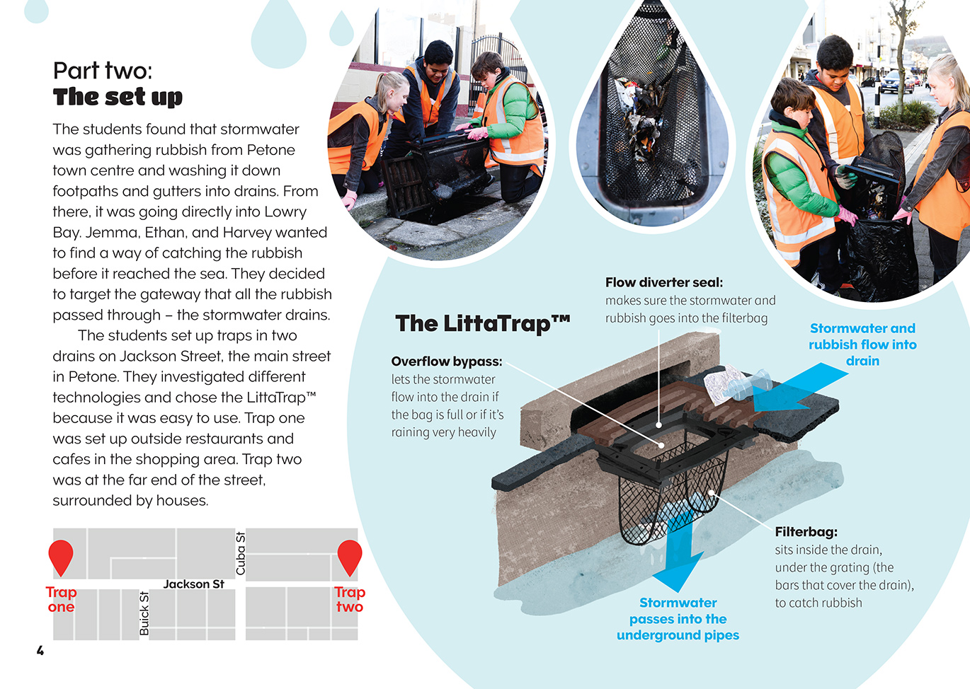 |  | Students gather and interpret data about a local real-life science situation.  Students take an interest in a scientific issue.  Students explore and act on an issue linked to their science learning and their daily living.
Technological outcomes are fit for purpose.
[Grab your reader’s attention with a great quote from the document or use this space to emphasize a key point. To place this text box anywhere on the page, just drag it.]

Learning activities – Exploring the science
The following activities and suggestions are designed as a guide for supporting students to explore and develop understandings about the science capability “engage with science”. Some activities focus directly on the science capability. Other activities extend student content knowledge across the learning areas. Adapt these activities to support your students’ learning needs.

Activity 1 – Taking action on rubbish
The students combined active citizenship with a simple piece of technology. Their actions were covered by several media sources, some of which are listed in the resource links. Invite your students to ask further questions about what the Wilford School students did, and what they found out. Have them follow the links to read the items and seek answers to their questions.
Prompt the students to make links to their own context.
Do we have similar issues with rubbish in our local community? Or at our school?
What do we know about them? Where does the rubbish go? How does it affect the environment?
What happens to the stormwater in our local environment?
How could we find out more?
Have the students plan and carry out an investigation into what happens to rubbish in their school or local area and how it could be better managed. Have them select a focus that they care about and can do something about. Consider the following ideas:
Collect and analyse the school’s rubbish, then develop, propose and implement a way of reducing the amount of rubbish and its impact on the environment.
Investigate rubbish in a natural environment near the school, then use the evidence to determine its source and identify solutions to the problem.
Go onto the local, regional, or city council website to find out about stormwater. Generate questions in preparation for a visit to the council or from a council officer. Use what they have learned to raise community awareness of how to reduce the amount of rubbish entering the stormwater system.
If the students choose to collect and analyse rubbish, support them to use the method described in the article over a longer period of time or over a greater area.
Encourage the students to critique the way the Wilford School students analysed their data.
What assumptions did they make?
What other ways could they have analysed the data?
How could they improve data collection to give a more accurate prediction of the amount of rubbish going down the drains?

Taking action for change
Have the students find out more about “drains to sea” plaques on drains.
Do we have them in our community? Should we? How could we persuade our community to get them? What arguments could we use? How could we present these arguments?
Do we have other ideas for how we could make people aware of the importance of keeping rubbish out of the stormwater system?

Activity 2 – From the beach to the sea
The Wilford School students initiated their investigation after going snorkelling at a local beach and being startled by the amount of rubbish under the water. Initiate a discussion about what happens next.
Where do you think all that rubbish goes? How far will it go?
Will it break down?
Do you think there is a difference in the impact of different kinds of rubbish?
Have the students read the Connected 2013 article “Giving the Ocean a Voice” and the Science Learning Hub item “Oceans of Rubbish”. They may be surprised to learn that nearly half the rubbish is plastic and that even tiny amounts of plastic can have a devastating effect on sea creatures.
Provide the students with the opportunity to see for themselves how long it can take items to degrade by conducting the biodegradability experiment on the Science Learning Hub.
Taking action for change
Play Tim Minchin’s video, Canvas Bags.
How could we encourage people to take canvas bags to the supermarket instead of using the plastic bags that are supplied?
What are some other examples of when we use lots of plastic (for example, plastic straws, take-away cup lids)? What alternatives could we suggest? How could we persuade people to consider these alternatives?

Learning activities – Exploring the science

Activity 3 – Where does the rain go?
Have the students reread page 3. Explain the concept of a model: that scientists and engineers often use models to represent their ideas about what an object, process, or system might look like and to test their ideas about how it works.  Provide the students with materials to construct models of a range of environments. Give them watering cans and have them observe and record what happens when they pour water over their environments. (See Making Better Sense of the Planet Earth and Beyond, page 35).  On the basis of the students’ observations, discuss the impact of urbanisation.  How does it affect natural processes when we build cities?  What can happen when there are lots of hard surfaces and not enough drains?  How could we improve the design of our towns and cities to avoid flooding? | Invite an urban planner or hydro engineer to talk about what is currently done to manage water in their local area and for the students to get feedback about their ideas for what might be done in the future.  Taking action for change  Have the students review their ideas and create models to test them, then present their models to each other for evaluation. If they feel they have developed fresh new ideas that could work, they could present their models to the local council.

RESOURCE LINKS

Making Better Sense of the Planet Earth and Beyond  Three-dimensional models of landforms activity: Making Better Sense of Planet Earth and Beyond, page 35.  Connected and School Journal  “Up the Pipe”, School Journal , Level 3, November 2014 http://instructionalseries.tki.org.nz/Instructional-Series/School-Journal/School-Journal-Level-3-November-2014/Up-the-Pipe  “Giving the Ocean a Voice”, Connected 2013, level 2, I Spy … http://instructionalseries.tki.org.nz/Instructional-Series/Connected/Connected-2013-level-2-I-Spy/Giving-the-Ocean-a-Voice  Science Learning Hub  Oceans of rubbish: www.sciencelearn.org.nz/resources/2074-oceans-of-rubbish  Biodegradability experiment: www.sciencelearn.org.nz/resources/1549-biodegradability-experiment | Other sources  Mountains to Sea Kaitiaki Stormwater Action Project Jackson Street Petone: http://mountainstoseawellington.org/petone-stormwater/  Stuff – Students find Wellington Harbour flooded with rubbish: www.stuff.co.nz/environment/84561922/Students-find-Wellington-Harbour-flooded-with-rubbish  Greater Wellington Regional Council – Save the drain for rain: www.gw.govt.nz/save-the-drain-for-rain/  Wellington Water – Turning on the tap: https://wellingtonwater.co.nz/your-water/education/turning-on-the-tap  Dunedin City Council – Preventing stormwater pollution: www.dunedin.govt.nz/services/stormwater/preventing-stormwater-pollution  Canvas Bags by Tim Minchin video: www.youtube.com/watch?v=EVh15aUt8-c  Enviroschools: Save the Drains: www.enviroschools.org.nz/in_your_region/wellington/FINAL_draft__for_trial_years_1-3_Kickstart_drains_are_for_rain.pdf

Learning activities – Exploring the technology

Activity 1 – Taking action on rubbish  Have the students look closely at the design of the LittaTrapTM and identify the features that make it fit for purpose. Working in pairs, have the students write paragraphs explaining how it works. Prompt further questioning:How does it affect natural processes when we build cities?  Who uses the LittaTrapTM?  Why aren’t drains designed to stop large objects entering them?  What do you think engineers need to consider when designing litter traps? How might this be affected by different environments?  Note that the article states that the students “investigated different technologies and chose the LittaTrapTM because it was easy to use” (page 4). Have the students research similar technologies and evaluate whether they agree that the LittaTrapTM would be easiest to use and why.  Have the students apply their thinking to the process of designing, developing, and building their own litter traps. | Activity 2 – Innovation or invention?  Introduce the concept of innovation:  “Innovation” is a word you hear a lot these days. What do you think it means? What is so great about it? What is the difference between an “innovation” and an “invention”?  Have the students share their ideas, capturing them on a Venn diagram.  Have the students carry out the Science Learning Hub activity “Invention or Innovation?” They can refine their existing diagrams as they work through the activity.  Invite the students to use what they have learned to evaluate whether the LittaTrapTM is an innovative technology. They should then read about the two examples of sustainable solutions on page 8.  Do these examples meet your criteria for “innovation”?  Have the students investigate other examples of new technology being used to manage stormwater. Have them work in groups to share what they have found and use this as inspiration for developing innovative new ideas of their own. They could create models that they could take out and test.

RESOURCE LINKS

Science Learning Hub  Introducing innovation: www.sciencelearn.org.nz/resources/1699-introducing-innovation  Innovation – key terms: www.sciencelearn.org.nz/resources/1698-innovation-key-terms  Invention or innovation? www.sciencelearn.org.nz/resources/1695-invention-or-innovation  Innovation – an integrated approach to science and technology (case study on using Science Learning Hub resources to learn about innovation): www.sciencelearn.org.nz/resources/1697-innovation-an-integrated-approach-to-science-and-technology | Other sources  Stormwater 360°: www.stormwater360.co.nz/  Stormwater 360° – LittaTrapTM: www.stormwater360.co.nz/products/stormwater-management/gross-pollutant-traps/prod/LittaTrap-  Curious Minds – What’s going down the drain in your street? www.curiousminds.nz/stories/whats-going-down-the-drain-in-your-street/

